Steps for installing MYSQL
STEP 01: Visit the official MYSQL website.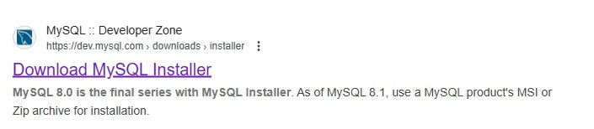
STEP 02: Choose the MYSQL installer for windows; you can select the web installer or the full installer.
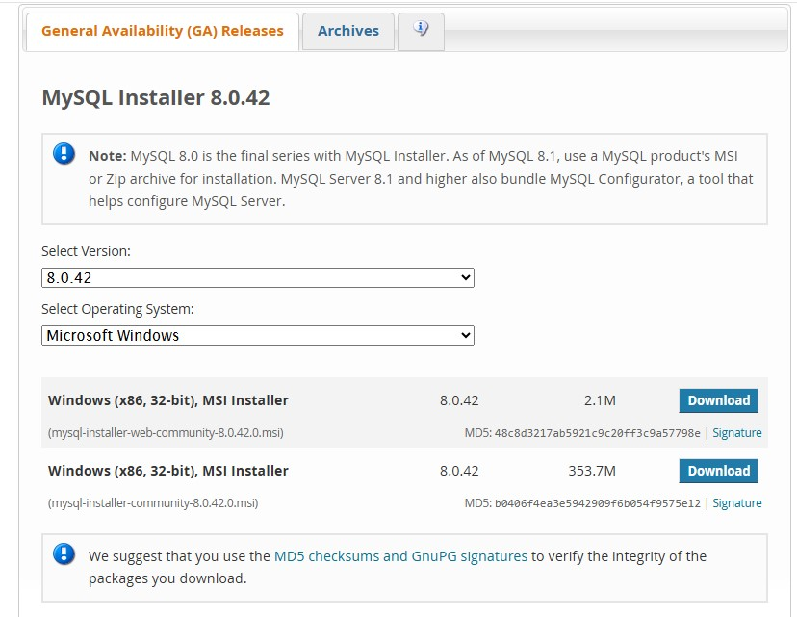STEP 03: After downloading, run the installer you might need to allow the installer to make changes to your system.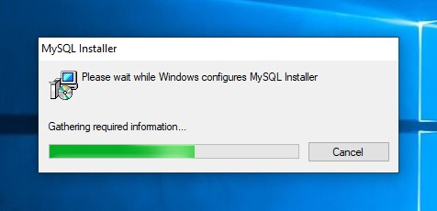
STEP 04: If you already have mysql ,you can choose custom or upgrade.
STEP 05: then add the products to be installed.
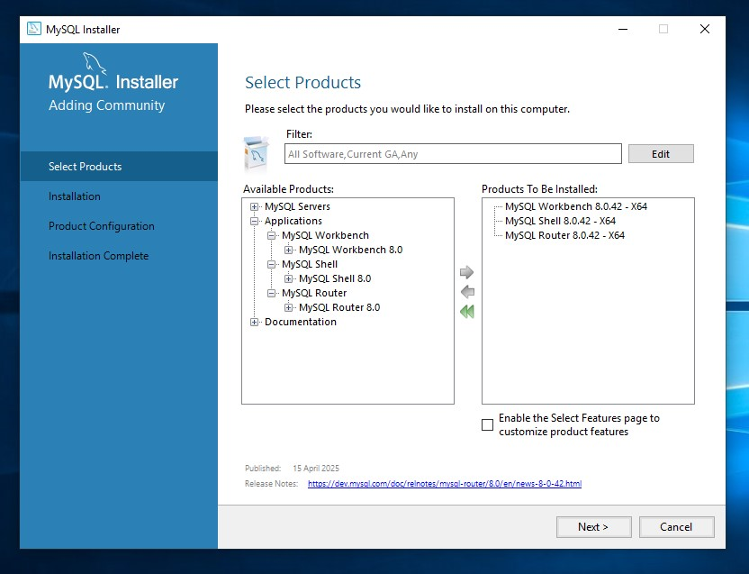
STEP 06: Choose standard mysql server and set the root password then you can configure port number and decide whether you want mysql to start automatically with windows.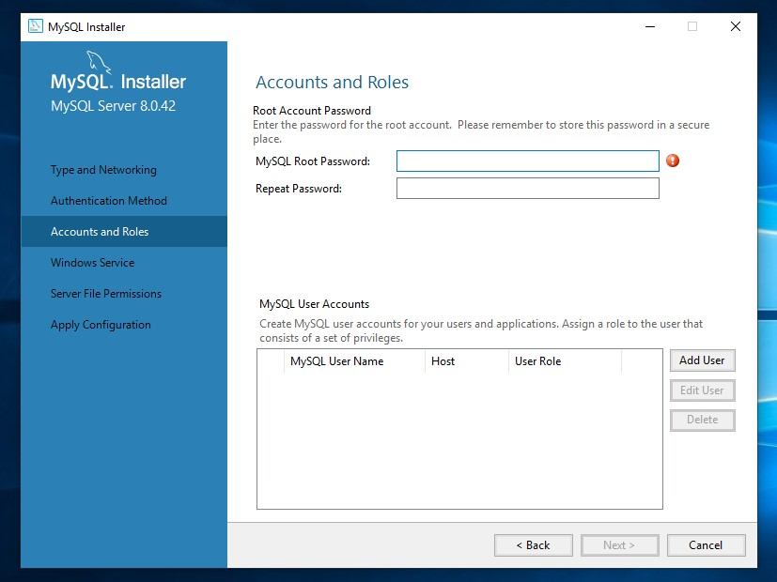
STEP 07: open the mysql workbench and enter the password to open.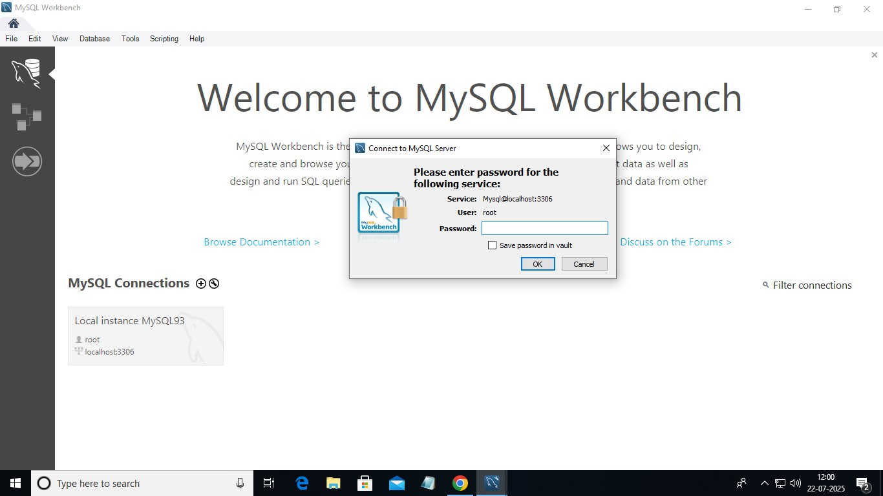
STEP 08: now you can start coding.